#Create a pipeline type job:

go to any pipeline which already created and click on pipeline syntax
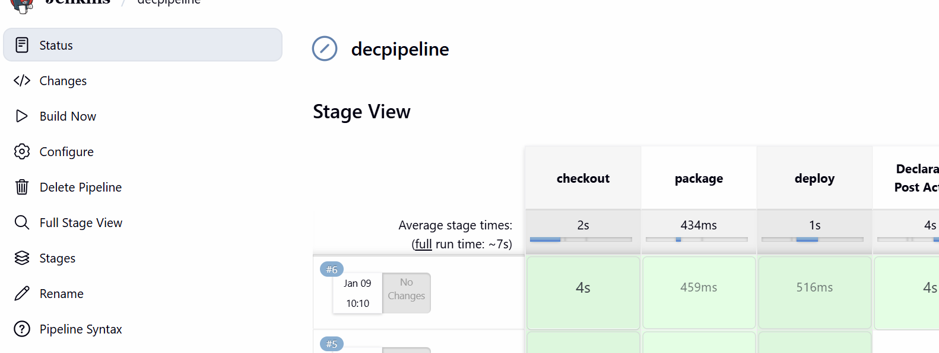
Click on Declarative Directive Generator

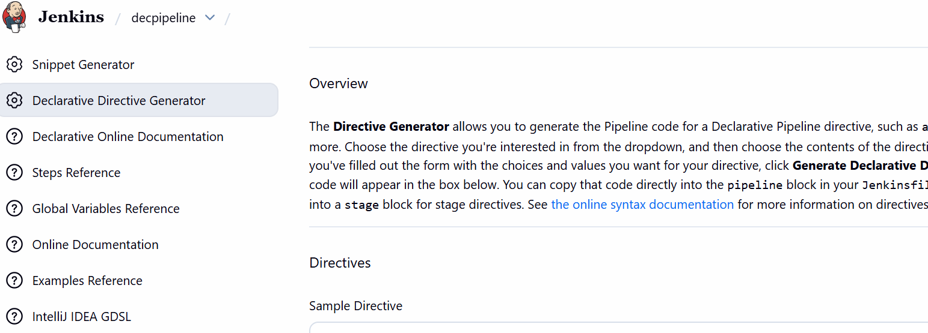

Provide details

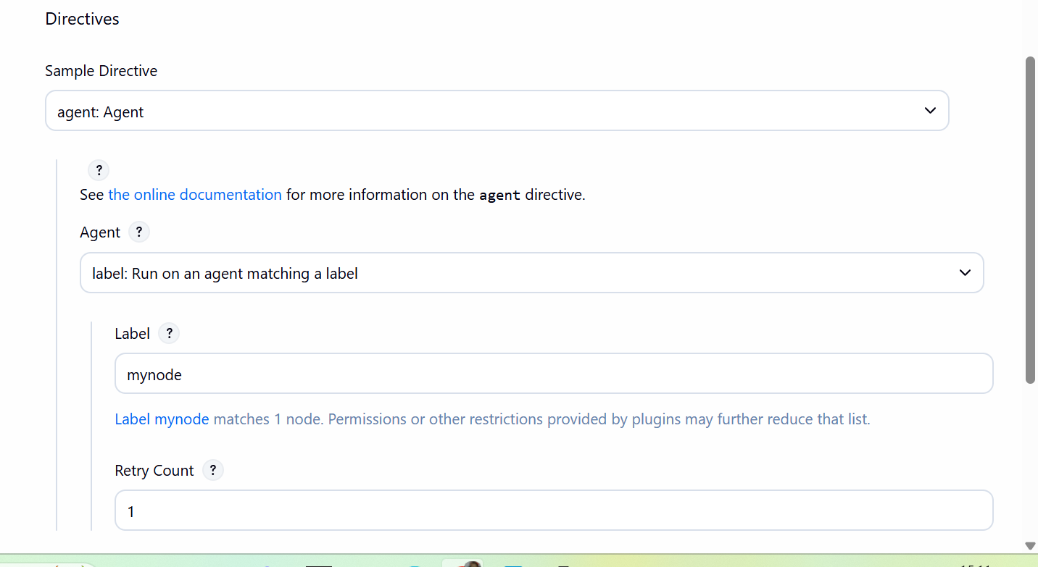

Generate code
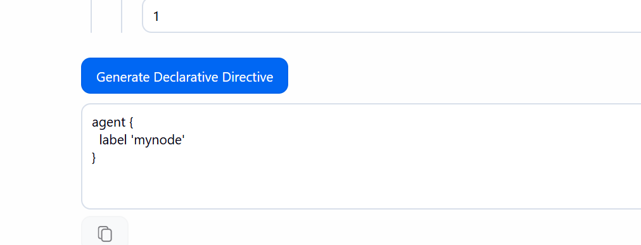

Go to pipeline codeagent section
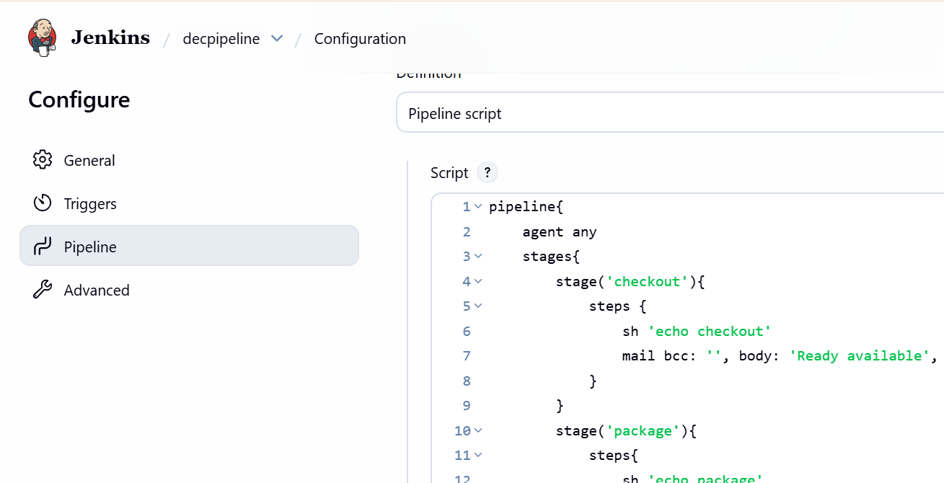

Replace with new code

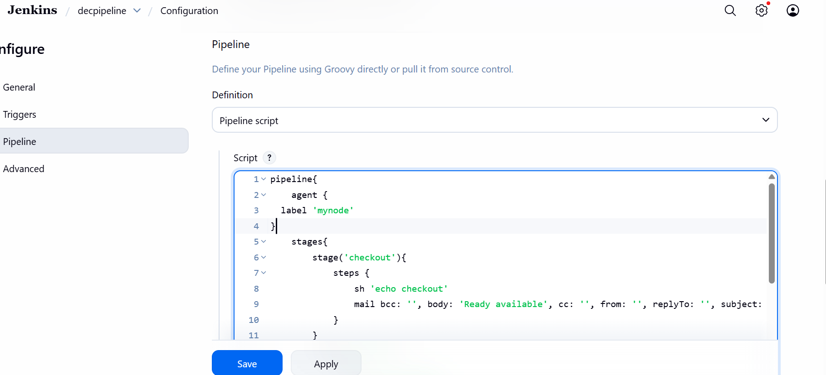

pipeline{
agent {
label 'mynode'
}
stages{
stage('checkout'){
steps {
sh 'echo checkout'
}
}
stage('package'){
steps{
sh 'echo package'
}
}
stage('deploy'){
steps{
sh 'echo deploy'

}
}
}
post {
always {
sh 'echo hello'
}
}
}
Save and build now

Check the console output of the job

